**SPRINT 3**

**DEVELOP THE WEB APPLICATION USING NODE-RED**

|  |  |
| --- | --- |
| **TEAM ID** | **PNT2022TMID43096** |
| **PROJECT NAME** | **GAS LEAKAGE MONITORING AND ALERTING SYSTEM FOR INDUSTRIES** |

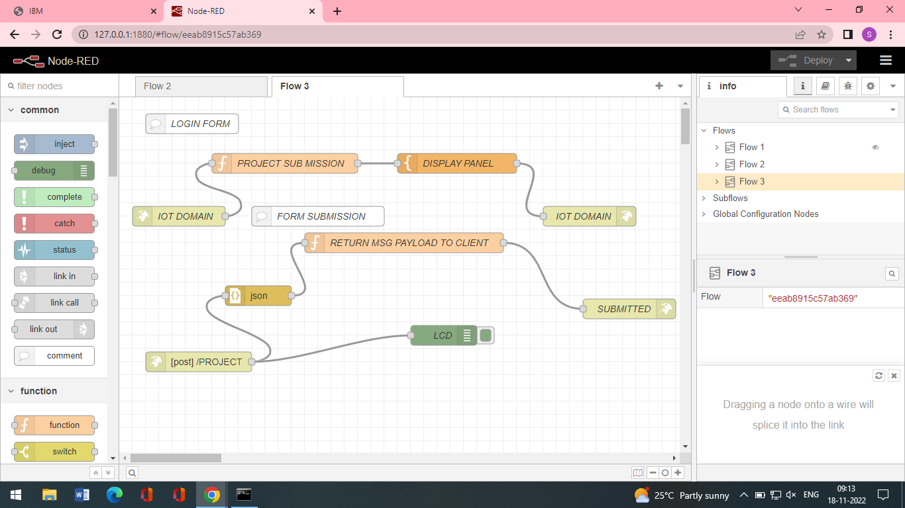

**OUTPUT**

